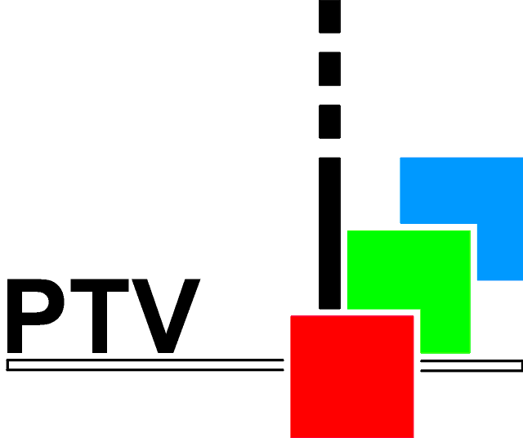
ProTeleVision Technologies
Participants during User Requirement Study Analysis Date:
Customer Representative | Company | Function
ProTeleVision Representatives

Sync, Test and Time Code Generator
User Requirements Questionnaire

Genlock Functions

Genlock

Genlock, Types of signals

Genlock Timing

Transparent Genlock

GPS genlock

Analog Composite Outputs

BlackBurst Outputs

User defined patterns or test signals (logo or special signals)

Timing resolution

Timing adjustment range

Source Identification Text

Field Identification

Mixed sync and continuos subcarrier

Analog synchronization pulses

Multi Standard Operation (NTSC and PAL)

Analog Component (RGB or YP_{B}P_{R}) Test Generator

Analog Component Test Generator

User defined patterns or test signals (logo or special signals)

Timing adjustment range

Timing resolution

Source Identification Text

Multi Standard Operation

SDI Outputs

Digital Black Outputs

Digital Field Identification

User defined patterns or test signals (logo or special signals)

Zone Plate Test Signal

Timing adjustment range

Source Identification Text

Video index information

Embedded Audio/Silence

Embedded Audio Groups

Embedded Audio Channels

Embedded Audio, selection of silence simultaneous with tone

Multi Standard Operation

HDTV signal generation

AES/EBU Audio

AES/EBU Audio Generator Outputs

AES/EBU Audio, alternative connectors

AES/EBU Audio Generator Output Signal

AES/EBU Audio Generator Timing

Time Code Functions

Transparent timing

Types of Time Code

Change Over Unit Control

Internal signal error testing

Improved power supply in the change over.

Remote Control

Remote Interface (serial / parallel)

Remote Communication Protocol

Remote Control Software

Upload and Download

Error Handling

Error logging

Modular construction

Possibility to Include more Modules

Maximum Number of Outputs

Service and Delivery

Repair and Service

Repair by use of exchange units or modules

Delivery Time of New Units

Operational Manual

Service Manual

Calibration Certificate

